SMART AC SYSTEMS

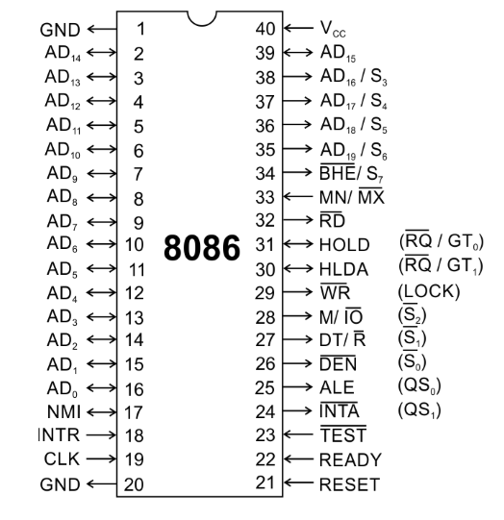

Group 82

## CS/EEE/ECE/INSTR F241 –

## MICROPROCESSOR PROGRAMMING AND INTERFACING

**A REPORT**

**ON**

**“SMART AC SYSTEMS”**

**PREPARED FOR**

***Prof. K. R. Anupama***

***Department of Electrical and Electronics Engineering***

**By**

2018A3PS0277G NILAY SANJAY NAIK

2018A8PS0064G SUMUKH DATTARAM PINGE

2018A8PS0019G PRATIK PATIL

2018A3PS0550G YASH KHANNA

2018A8PS0442G VATSAL AGARWAL

In partial fulfilment of the requirements of

EEE/INSTR F241, Microprocessor Programming & Interfacing



April 2020

**Table of Contents**

1. PROBLEM STATEMENT3

2. ASSUMPTIONS 4

3. SYSTEM DESCRIPTION5

4. HARDWARE DEVICES6

5. I/O MAPPING7

6. ADDRESS MAPPING8

7. WORKING9

8. ALGORITHM / FLOWCHART10

9. DESIGN12

10. VARIATIONS IN PROTEUS IMPLEMENTATION 13

11. CODE14

12. LIST OF ATTACHMENT31

1. **PROBLEM STATEMENT**

**Question 12-**

**Description**

1. This system opens/closes six AC vents based upon the current temperature in the Room.
2. The temperature is maintained at a pleasant 20 –25-degree C. The AC vents can be gradually opened / closed. This is done in accordance with the temperature in the room.
3. The room is a fairly large sized room so 6 temperature sensors are placed at different points of the room.
4. Each sensor and AC vent are associated with part of the room.
5. You can assume that the room is broken up into 6 sub-areas each with its own sensor and ac vent.

**User Interface:**

1. Air-conditioner starts when user presses ‘Start’ button. User can also set the required temperature by using a keypad interface.
2. This temperature value should be displayed on a 7-segment display.
3. After setting temperature initially, user should be able to change the temperature setting by an up and down switch.
4. Each press on this arrow button increases/ decreases the temperature by one degree Celsius.
5. Min temp value is 20 deg, whereas maximum temp value is 25 deg Celsius. Pressing ‘UP’ button after reaching to 25 deg C, should not change the display value or setting of AC. Same is true for lower bound.
6. Air-conditioner can be stopped by pressing ‘Stop’ button.
7. User can also set the mode of AC as ‘Bio-Sleep’ mode besides a ‘Regular mode’ setting.
8. In Bio-sleep mode, user should be able to enter the value of time in terms of hours after which the AC has to be switched off automatically. (For example, if value entered is 2, then the AC should switch off after 2 hours from the time this setting is applied).
9. **JUSTIFICATIONS AND ASSUMPTIONS**
10. ALP is already stored in the ROM in executable form.
11. The room is broken down into 6 parts. One sensor in placed in each part
12. The temperature of one part of room has no influence over the temperature of the other parts.
13. The temperature of each part of the room varies between 20-25◦C only.
14. As the value to be displayed is only between 20◦C to 25◦C and resolution is only 1◦C there is only a need for two seven segment displays.
15. If the temperature entered is greater than 25◦C it defaults to 25◦C. If lesser than 20◦C it defaults to 20◦C .
16. When the user presses the ON button, this starts the timer for polling the sensors.
17. When the temperature sensed by LM35 is less then Input Temp, the vent is closed.
18. The Vent is assumed to be closed at 0° reading.
19. Rotation of motor by 9 degree opens/closes the AC vent by one degree centigrade.
20. The motor reading (vent) is 36 degrees for fully open vent. When the difference in temperature sensed by the LM35 is >= 4°, The vent will be completely open.
21. Due to the slow nature of the Proteus Simulation, we have assumed 1 hour in real life as 1 minute for the simulations.
22. **SYSTEM DESCRIPTION**
23. **Intel 8086 microprocessor.**
24. **Input Device:**
    1. 6 temperature sensors.
    2. A 4x4 Matrix keypad.
25. **Output Devices:**
    1. 6 stepper motors to open/close AC vents.
    2. 2 seven segment displays to display temperature and timer.
26. **8086 works on a clock frequency of 2MHz.**
27. **8253 timer is used.**
    1. Clock 2 takes 5MHz input and generates 1MHz square wave output for ADC Clock and for input of Clock 1
    2. Clock 1 takes 1MHz input and gives 1KHz square wave output
    3. Clock 0 takes 1KHz input and gives approximately 2Hz output. This is the rate generator used for sensor polling
28. **Five 8255 (Programmable Peripheral Interface) chips interfaced to 8086.**
    1. **8255-A:** PortA is interfaced with the data lines of Seven Segment Display which shows LSB. PortB is interfaced to Seven Segment Display showing MSB. Port C is interfaced to 4X4 Matrix Keypad Input
    2. **8255-B:** PortA takes input from ADC0808 which is interfaced with the 6 temperature sensors LM35. PortB is used to select the input channel on ADC. PC4 is used for detecting end of conversion.PC0 is used to give start of conversion.
    3. **8255-C:** Port A, Port B, Port C are interfaced to the 1st-3rd stepper motors.
    4. **8255-D:** Port A, Port B, Port C are interfaced to the 4th-6th stepper motors.
    5. **8255-E:** Port A0 used to detect output of rate generator, Port B0 controls gate of rate generator.
29. **74138 3-8 decoder is used to select which I/O device to use.**
30. **HARDWARE DEVICES**

|  |  |  |
| --- | --- | --- |
| CHIP NUMBER | CHIP | PURPOSE |
| 8086 | MICROPROCESSOR | CENTRAL PROCESSING UNIT |
| 6116(2) | RAM-2k | RANDOM ACCESS MEMORY-CONTAINS DS, SS |
| 2732(2) | ROM-4K | READ ONLY MEMORY – CONTAINS ENTIRE CODE |
| 74LS373(3) | 8-BIT LATCH | TO LATCH ADDRESS BUS |
| 74LS245(2) | 8-BIT BUFFER | TO BUFFER DATA BUS (BIDIRECTIONAL) |
| 8255(5) | PROGRAMMABLE PERIPHERAL INTERFACE | CONNECTED TO VARIOUS I/O DEVICES |
| 8259 | PROGRAMMABLE  INTERRUPT  CONTROLLER (PIC) | TO ASSIGN PRIORITY TO VARIOUS INTURRUPTS  RAISED. |
| ADC0808(1) | ANALOG TO DIGITAL CONVERTER | CONVERTS ANALOG VOLTAGE SIGNAL TO DIGITAL FORM |
| CLOCK GENERATOR | CLOCK | CLOCK INPUT FOR 8086 AND CLOCK2 of 8253 |
| 8253(1) | TIMER | PRODUCES CLOCK FOR RATE GENERATOR AND ADC |
| STEPPER MOTOR(6) |  | FOR OPENING/CLOSING AC VENTS |
| SEVEN SEGMENT DISPLAY(2) |  | TO DISPLAY DESIRED TEMPERATURE |
| LM35(6) | TEMPERATURE SENSOR | TO MEASURE TEMPERATURE IN VARIOUS PARTS OF THE ROOM |
| 74138 | 3-8 DECODER | USED TO SELECT I/O DEVICE |

1. **I/O MAPPING**

**8255-A**

* PORT A- 00H
* PORT B – 02H
* PORT C – 04H
* CR - 06H

**8255-B**

* PORT A - 08H
* PORT B – 0AH
* PORT C – 0CH
* CR - 0EH

**8255-C**

* PORT A- 10H
* PORT B – 12H
* PORT C – 14H
* CR - 16H

**8255-D**

* PORT A- 18H
* PORT B – 1AH
* PORT C – 1CH
* CR - 1EH

**8253**

* PORT A- 20H
* PORT B – 22H
* PORT C – 24H
* CR - 26H

**8255-E**

* PORT A- 28H
* PORT B – 2AH
* PORT C – 2CH
* CR - 2EH

**8259**

* Base Address - 30H
* Address 2 – 32H

1. **ADDRESS MAPPING**

**MEMORY ORGANISATION:**

The system uses 4KB of RAM and 8KB of ROM. RAM Chip has a size of 2KB and ROM Chip has a size of 4KB. They are organized into odd and even bank to facilitate both byte and word size data transfers.

**Read Only Memory:**

Starting Address: 00000h Ending Address: 01FFFh

**Random Access Memory:**

Starting Address: 02000h Ending Address: 02FFFh

MEMORY MAPPING

|  |  |  |  |  |  |  |  |  |  |  |  |  |  |  |  |  |  |  |  |  |
| --- | --- | --- | --- | --- | --- | --- | --- | --- | --- | --- | --- | --- | --- | --- | --- | --- | --- | --- | --- | --- |
| CHIP | A19 | A18 | A17 | A16 | A15 | A14 | A13 | A12 | A11 | A10 | A9 | A8 | A7 | A6 | A5 | A4 | A3 | A2 | A1 | A0 |
|  |  |  |  |  |  |  |  |  |  |  |  |  |  |  |  |  |  |  |  |  |
| ROM1(8K) | 0 | 0 | 0 | 0 | 0 | 0 | 0 | 0 | 0 | 0 | 0 | 0 | 0 | 0 | 0 | 0 | 0 | 0 | 0 | 0 |
| To | 0 | 0 | 0 | 0 | 0 | 0 | 0 | 1 | 1 | 1 | 1 | 1 | 1 | 1 | 1 | 1 | 1 | 1 | 1 | 1 |
| RAM1(4K) | 0 | 0 | 0 | 0 | 0 | 0 | 1 | 0 | 0 | 0 | 0 | 0 | 0 | 0 | 0 | 0 | 0 | 0 | 0 | 0 |
| To | 0 | 0 | 0 | 0 | 0 | 0 | 1 | 0 | 1 | 1 | 1 | 1 | 1 | 1 | 1 | 1 | 1 | 1 | 1 | 1 |

1. **WORKING**

1) After pressing “ON” all vents are initially closed and the desired temperature defaults to 23◦C

2) The user specifies the initial temperature to be maintained by entering 2-digit temperature on the keypad. The user has to press the “SET TEMP” button if he has completed setting the temperature.

3) The temperature as sensed by the sensor is updated after every 0.5 seconds (2hz). This temperature is compared with the temperature required to be set. If the two are not same, the AC valve is opened or closed accordingly.

4) Whenever the user presses the T UP button or T DWN button required temperature is increased or decreased by 1◦C respectively.

6)To use the BIOSLEEP Mode, Enter the hours on the keypad and press the BIOSLEEP button. This starts a software delay equal to the number of hours currently on the display. If greater than 09, defaults to 09. After this delay AC switches off. Please note, this step should only come after we set the initial temperature.

5) When the user presses the OFF button, this closes all the vents and stops the timer.

1. **ALOGORITM / FLOWCHART**

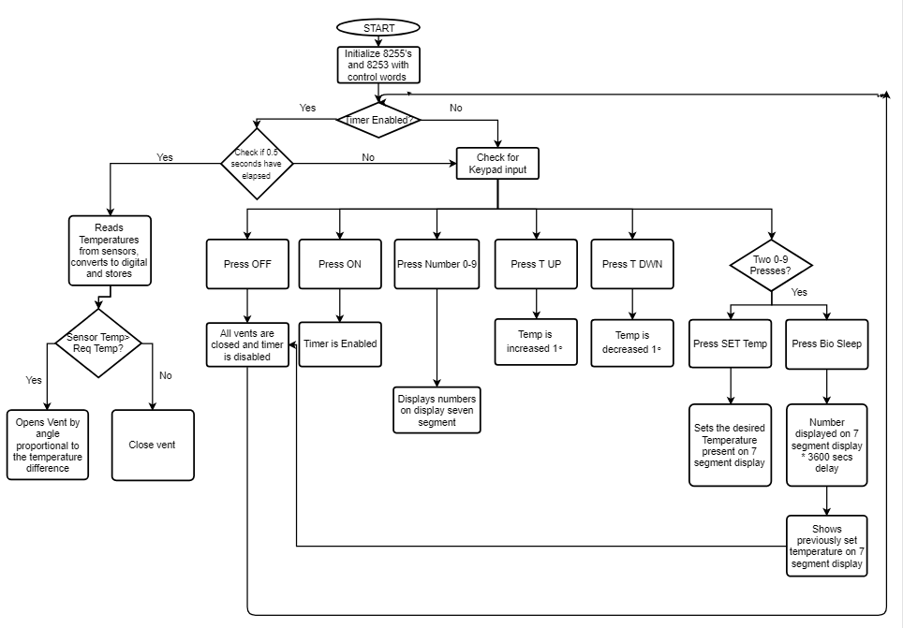

**ISR FLOW CHART**

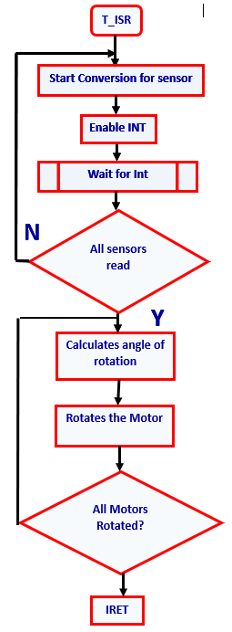

**9. DESIGN**

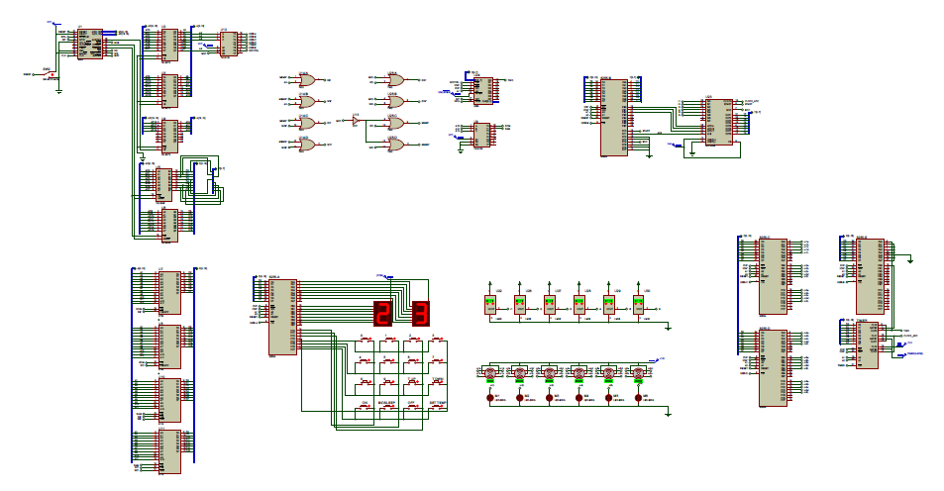

**Kindly refer to the “*****proteus_design.pdf”* file for labelled clearer view**

**10.** **VARIATIONS IN PROTEUS IMPLEMENTATION**

**WITH JUSTIFICATION**

* Used 8253 – as 8254 not available in Proteus.
* ROM in only 00000 – as proteus allows to change reset address.
* 2732 is used as 2716 – not available in Proteus.
* Temperature Sensor – used LM35 as it was best suited for project and was present in Proteus v8.6.

**11. CODE – IMPLEMENTED USING EMU8086**

#LOAD_SEGMENT=FFFFH

#LOAD_OFFSET=0000H

#AX=0000H

#BX=0000H

#CX=0000H

#DX=0000H

#SI=0000H

#DI=0000H

#BP=0000H

#CS=0000H

#IP=0000H

#DS=0000H

#ES=0000H

#SS=0000H

#SP=FFFEH

JMP ST1

DB 509 DUP(0)

DW T_ISR

DW 0000

DB 508 DUP(0)

; KEYPAD TABLE

KEYPAD_TABLE DB 0EEH,0EDH,0EBH,0E7H,0DEH,0DDH,0DBH,0D7H,0BEH,0BDH,0BBH,0B7H,07EH,07DH,07BH,077H

;DISPLAY TABLE

DISPLAY_TABLE DB 3FH,06H,5BH,4FH,66H, 6DH,7DH,27H,7FH,6FH

;ALL VARIABLES

KEY0 DB ?

KEY1 DB ?

TEMP0 DB ?

TEMP1 DB ?

TEMP DB ?

T_SENSOR1 DB ?

T_SENSOR2 DB ?

T_SENSOR3 DB ?

T_SENSOR4 DB ?

T_SENSOR5 DB ?

T_SENSOR6 DB ?

HOURS DB ?

CURRENT_PORT DB ?

CURRENT_TEMP DB ?

DISP DB ?

DB 465 DUP(0)

;PROGRAM START

ST1: CLI

; INTIALIZE DS, ES,SS TO START THE RAM

MOV AX,0200H

MOV DS,AX

MOV ES,AX

MOV SS,AX

MOV SP,0FFFEH

;INITIALIZE VARIABLES

MOV KEY0,00H

MOV KEY1,00H

MOV TEMP1,02H

MOV TEMP0,03H

MOV TEMP,23D

MOV T_SENSOR1,25D

MOV T_SENSOR2,25D

MOV T_SENSOR3,25D

MOV T_SENSOR4,25D

MOV T_SENSOR5,25D

MOV T_SENSOR6,25D

MOV HOURS,01H

MOV CURRENT_PORT,10H

MOV CURRENT_TEMP,17H

MOV DISP,01H

; 8255-A (STARTING 00H)

; INTIALISE KEYPAD

; UPPER PORT C AS INPUT ,PORT B ,PORT A AND LOWER PORT C AS OUTPUT

MOV AL, 10001000B

OUT 06H,AL

; 8255-B (STARTING 08H)

; INITIALIZE SENSORS

; PORT A AND UPPER PORT C AS INPUT, PORT B AND LOWER PORT C AS (GIVES) OUTPUT,

MOV AL, 10011000B

OUT 0EH, AL

; 8255-C (STARTING 10H)

;INITIALIZE MOTORS 1,2,3

;PORT A,B,C AS OUTPUT

MOV AL, 10000000B

OUT 16H, AL

; 8255-D (STARTING 18H)

;INITIALIZE MOTORS 4,5,6;

;PORT A,B,C AS OUTPUT

MOV AL, 10000000B

OUT 1EH, AL

;INITIALIZE TIMER 8253. (STARTING 20H)

;CLOCK 0 IN MODE 2 WITH 1KHZ INPUT

;CLOCK 1 IN MODE 3 WITH 1MHZ INPUT

;CLOCK 2 IN MODE 3 WITH 5MHZ INPUT

MOV AL, 00110100B

OUT 26H, AL

MOV AL, 01110110B

OUT 26H, AL

MOV AL, 10110110B

OUT 26H, AL

;SEND COUNT OF 01F4H = 500D TO CLOCK 0

;SEND COUNT OF 03E8H = 1000D TO CLOCK 1

;SEND COUNT OF 0005H = 5D TO CLOCK 2

MOV AL,0F4H

OUT 20H,AL

MOV AL,01H

OUT 20H,AL

MOV AL,0E8H

OUT 22H,AL

MOV AL,03H

OUT 22H,AL

MOV AL,05H

OUT 24H,AL

MOV AL,00H

OUT 24H,AL

;OUT CLOCK 0 = 2HZ.

;OUT CLOCK 1 = 1KHZ.

;OUT CLOCK 2 = 1MHZ.

;INITIALIZE TIMER 8255-E

;PORT A INPUT,PORT B PORT C OUTPUT 28H

MOV AL, 10010000B

OUT 2EH, AL

MOV AL,00H

OUT 2AH, AL

;8259 - ENABLE IRO ALONE, USE AEOI MODE

MOV AL,00010011B

OUT 30H,AL

MOV AL,80H

OUT 32H,AL

MOV AL,03H

OUT 32H,AL

MOV AL,0FEH

OUT 32H,AL

STI

;INITIALIZE DISPLAY WITH 23 DEGREES.

MOV AL,4FH

NOT AL

OUT 00H,AL

MOV AL,5BH

NOT AL

OUT 02H,AL

;CHECK FOR KEY RELEASE -DEBOUNCE DELAY:

X0:

MOV DH,00H

MOV AL,00H

OUT 04H,AL

X1:

IN AL,04H

AND AL,0F0H

CMP AL,0F0H

JNZ X1

CALL D20MS

;CHECKS FOR BIOSLEEP TIMER THEN POLLING THEN CHECKS FOR KEY PRESS:

MOV AL,00H

OUT 04H ,AL

X2: IN AL, 04H

AND AL,0F0H

CMP AL,0F0H

JZ X2

CALL D20MS

MOV AL,00H

OUT 04H ,AL

IN AL, 04H

AND AL,0F0H

CMP AL,0F0H

JZ X2

;=========================================================================================================================================================

;DECODES KEY MATRIX

;CHECK COLUMN 0

MOV AL, 0EH

MOV BL,AL

OUT 04H,AL

IN AL,04H

AND AL,0F0H

CMP AL,0F0H

JNZ X3

;CHECK COLUMN 1

MOV AL, 0DH

MOV BL,AL

OUT 04H ,AL

IN AL,04H

AND AL,0F0H

CMP AL,0F0H

JNZ X3

;CHECK COLUMN 2

MOV AL, 0BH

MOV BL,AL

OUT 04H,AL

IN AL,04H

AND AL,0F0H

CMP AL,0F0H

JNZ X3

;CHECK COLUMN 3

MOV AL, 07H

MOV BL,AL

OUT 04H,AL

IN AL,04H

AND AL,0F0H

CMP AL,0F0H

JZ X2

;DECODE THE KEY

X3:

OR AL,BL

MOV CX,0FH

MOV DI,00H

X4:

CMP AL,CS:KEYPAD_TABLE[DI]

JZ X5

INC DI

INC DH

LOOP X4

;DISPLAY THE KEY

X5:

CMP DH,09H

JG BUTTON

LEA BX, DISPLAY_TABLE

MOV AL, CS:[BX+DI]

NOT AL

MOV DL,DISP

CMP DL,00H

JNE X6

OUT 00H,AL

XOR DL,01H

MOV DISP,DL

MOV KEY0,DH

JMP X0

X6:

OUT 02H,AL

XOR DL,01H

MOV DISP,DL

MOV KEY1,DH

JMP X0

;IF BUTTON PRESSED IS NOT A NUMBER, THIS PROCEDURE CHECKS WHICH BUTTON AND JUMPS TO THE PROCEDURE

BUTTON:

CMP DH,0AH

JE T_UP

CMP DH,0BH

JE T_DWN

CMP DH,0CH

JE ON

CMP DH,0DH

JE BIOSLEEP

CMP DH,0EH

JE OFF

CMP DH,0FH

JE DEFAULT

JMP X0

;INCREASE TEMPERATURE BY 1 DEGREE(MAX 25 DEGREES)

T_UP:

MOV CL,TEMP0

CMP CL,05H

JE X0

INC CL

MOV TEMP0,CL

MOV AL,TEMP

ADD AL,1

MOV TEMP,AL

CALL DISPLAY0

JMP X0

;DECREASE TEMPERATURE BY 1 DEGREE(MIN 20 DEGREES)

T_DWN:

MOV CL,TEMP0

CMP CL,00H

JE X0

DEC CL

MOV TEMP0,CL

MOV AL,TEMP

SUB AL,1

MOV TEMP,AL

CALL DISPLAY0

JMP X0

;STARTS RATE GENERATOR FOR TAKING INPUT FROM SENSORS PERIODICALLY

ON:

;STARTS TIMER

MOV AL,01H

OUT 2AH, AL

JMP X0

;SETS SLEEP TIMER(UPTO 9 HOURS),AFTER TAKING INPUT RESETS DISPLAY TO TEMPERATURE

BIOSLEEP:

MOV AL,KEY1

MOV BL,KEY0

MOV AH,00

MOV CL,0AH

MUL CL

ADD AL,BL

CMP AX,0009H

JG HOURH

MOV HOURS,AL

CALL DISPLAY0

CALL DISPLAY1

JMP TIMER_START

HOURH:

MOV HOURS,09H

CALL DISPLAY0

CALL DISPLAY1

JMP TIMER_START

;DISABLES RATE GENERATOR, SHUTS ALL AC VENTS

OFF:

MOV AL,06H

OUT 10H,AL

OUT 12H,AL

OUT 14H,AL

OUT 18H,AL

OUT 1AH,AL

OUT 1CH,AL

MOV AL,00H

OUT 2AH, AL

JMP X0

;SETS TEMPERATURE EQUAL TO NUMBER CURRENTLY ON DISPLAY, IF >25, AUTOMATICALLY SETS TO 25,SAME WITH <20

DEFAULT:

MOV AL,KEY1

MOV TEMP1,AL

MOV CL,0AH

MUL CL

MOV CL,KEY0

MOV TEMP0,CL

ADD AL,CL

MOV TEMP,AL

CMP AL,25D

JG DEFH

CMP AL,20D

JL DEFL

JMP X0

DEFH:

MOV TEMP1,02H

MOV TEMP0,05H

MOV AL,25D

MOV TEMP,AL

CALL DISPLAY0

CALL DISPLAY1

JMP X0

DEFL:

MOV TEMP1,02H

MOV TEMP0,00H

MOV AL,20D

MOV TEMP,AL

CALL DISPLAY0

CALL DISPLAY1

JMP X0

;MULTIPLIES USER INPUT WITH 135 AND STARTS SLEEP TIMER

;1MIN/0.45(DELAY)~135

TIMER_START:

MOV BL,HOURS

MOV AX,0135D

MUL BL

DHOUR:

CALL D1S

DEC AX

JNZ DHOUR

JMP OFF

JMP X0

;COMPARES TEMPERATURE ENTERED WITH POLLED TEMPERATURE AND MOVES VENT ACCORDING THE CALCULATIONS

MOTOR:

MOV BL,TEMP

MOV AL,CURRENT_TEMP

SUB AL,BL

CMP AL,01H

JE P1

CMP AL,02H

JE P2

CMP AL,03H

JE P3

CMP AL,04H

JGE P4

JMP NO

NO:

MOV DL,CURRENT_PORT

MOV DH,00H

MOV AL,06H

OUT DX,AL

RET

P1:

MOV DL,CURRENT_PORT

MOV DH,00H

MOV AL,12H

OUT DX,AL

RET

P2:

MOV DL,CURRENT_PORT

MOV DH,00H

MOV AL,13H

OUT DX,AL

RET

P3:

MOV DL,CURRENT_PORT

MOV DH,00H

MOV AL,11H

OUT DX,AL

RET

P4:

MOV DL,CURRENT_PORT

MOV DH,00H

MOV AL,19H

OUT DX,AL

RET

;CHECKS FOR EOC

CONV:

IN AL,0CH

AND AL,0F0H

CMP AL,10H

JNE CONV

RET

;UPDATE LSB OF DISPLAY

DISPLAY0:

MOV CL,TEMP0

MOV CH,00H

MOV DI,CX

LEA BX, DISPLAY_TABLE

MOV AL,CS:[BX+DI]

NOT AL

OUT 00H,AL

RET

;UPDATE MSB OF DISPLAY

DISPLAY1:

MOV CL,TEMP1

MOV CH,00H

MOV DI,CX

LEA BX, DISPLAY_TABLE

MOV AL,CS:[BX+DI]

NOT AL

OUT 02H,AL

RET

;GENERATES DEBOUNCE DELAY

D20MS:

MOV CX,20 ; DELAY GENERATED

XN:

LOOP XN

RET

D1S:

MOV CX,50000 ; DELAY GENERATED IS 0.45S

XS:

LOOP XS

RET

T_ISR:

PUSH AX

;SELECT SENSOR 1

MOV AL,00H

OUT 0AH,AL

;HIGH TO LOW TRANSITION ON START AND ALE

MOV AL,00H

OUT 0CH,AL

MOV AL,03H

OUT 0CH,AL

MOV AL,00H

OUT 0CH,AL

;WAIT FOR CONVERSION

CALL CONV

;STORE READ TEMPERATURE

IN AL,08H

MOV T_SENSOR1,AL

;SELECT SENSOR 2

MOV AL,01H

OUT 0AH,AL

;HIGH TO LOW TRANSITION

MOV AL,00H

OUT 0CH,AL

MOV AL,03H

OUT 0CH,AL

MOV AL,00H

OUT 0CH,AL

;WAIT FOR CONVERSION

CALL CONV

;STORE READ TEMPERATURE

IN AL,08H

MOV T_SENSOR2,AL

;SELECT SENSOR 3

MOV AL,02H

OUT 0AH,AL

;HIGH TO LOW TRANSITION

MOV AL,00H

OUT 0CH,AL

MOV AL,03H

OUT 0CH,AL

MOV AL,00H

OUT 0CH,AL

;WAIT FOR CONVERSION

CALL CONV

;STORE READ TEMPERATURE

IN AL,08H

MOV T_SENSOR3,AL

;SELECT SENSOR 4

MOV AL,03H

OUT 0AH,AL

;HIGH TO LOW TRANSITION

MOV AL,00H

OUT 0CH,AL

MOV AL,03H

OUT 0CH,AL

MOV AL,00H

OUT 0CH,AL

;WAIT FOR CONVERSION

CALL CONV

;STORE READ TEMPERATURE

IN AL,08H

MOV T_SENSOR4,AL

;SELECT SENSOR 5

MOV AL,04H

OUT 0AH,AL

;HIGH TO LOW TRANSITION

MOV AL,00H

OUT 0CH,AL

MOV AL,03H

OUT 0CH,AL

MOV AL,00H

OUT 0CH,AL

;WAIT FOR CONVERSION

CALL CONV

;STORE READ TEMPERATURE

IN AL,08H

MOV T_SENSOR5,AL

;SELECT SENSOR 6

MOV AL,05H

OUT 0AH,AL

;HIGH TO LOW TRANSITION

MOV AL,00H

OUT 0CH,AL

MOV AL,03H

OUT 0CH,AL

MOV AL,00H

OUT 0CH,AL

;WAIT FOR CONVERSION

CALL CONV

;STORE READ TEMPERATURE

IN AL,08H

MOV T_SENSOR6,AL

;=============================================================================

; UPDATE MOTORS

MOV AL,T_SENSOR1

MOV CURRENT_TEMP,AL

MOV CURRENT_PORT,10H

CALL MOTOR

MOV AL,T_SENSOR2

MOV CURRENT_TEMP,AL

MOV CURRENT_PORT,12H

CALL MOTOR

MOV AL,T_SENSOR3

MOV CURRENT_TEMP,AL

MOV CURRENT_PORT,14H

CALL MOTOR

MOV AL,T_SENSOR4

MOV CURRENT_TEMP,AL

MOV CURRENT_PORT,18H

CALL MOTOR

MOV AL,T_SENSOR5

MOV CURRENT_TEMP,AL

MOV CURRENT_PORT,1AH

CALL MOTOR

MOV AL,T_SENSOR6

MOV CURRENT_TEMP,AL

MOV CURRENT_PORT,1CH

CALL MOTOR

POP AX

IRET

1. **LISTS OF ATTACHMENTS**

# 

**Convert to oC**

**Display Temp**

**Wait for**

**2 min INT**

1. Hardware.pdf.
2. Proteus File – Smart_AC-Proteus.pdsprj
3. Manuals
   1. ADC 0808
   2. LM35
   3. Stepper Motor
4. EMU8086 ASM File – Smart_AC.asm
5. Binary File after assembly – SmartAC.bin
6. On Paper design - proteus_design.pdf